MDHHS – MCIR Release Notes

Version 2024 – MCIR OLTP 2024 24.4.24 – RFC 235408 Release Date: 04/24/2024

Forecasting & Assessment – 5 Items

1. After dose 1 of PCV/PPSV23 (trigger assessment), forecast dose 2 of pneumococcal vaccination. (Ref# 850)

* New adult Pneumo assessment based on age and history for 6yrs through 64 years
* This is a trigger assessment if dose one is given, dose two will be forecasted if necessary.
* [PneumoRecs Vax Advisor App](https://www.cdc.gov/vaccines/vpd/pneumo/hcp/pneumoapp.html) was utilized as reference for those patients with chronic medical conditions.
  + Those with immunocompromising conditions, who may require a minimal interval of 8 weeks , will be accepted by MCIR

Status screen:



Immunization record

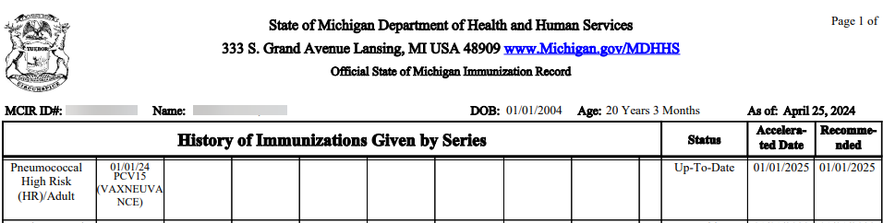

1. Forecast for 65 years and older 1 additional dose of any updated (23–24 Formula) COVID-19 vaccine at least 4 months after previous dose of updated (23–24 Formula) COVID-19 vaccine. (Ref# 2833)

Status screen:

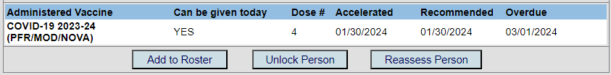

Use the following links for additional guidance:

[Clinical Guidance for COVID-19 Vaccination | CDC](https://www.cdc.gov/vaccines/covid-19/clinical-considerations/interim-considerations-us.html#table-01)

[Use of an Additional Updated 2023–2024 COVID-19 Vaccine Dose for Adults Aged ≥65 Years: Recommendations of the Advisory Committee on Immunization Practices — United States, 2024 | MMWR (cdc.gov)](https://www.cdc.gov/mmwr/volumes/73/wr/mm7316a4.htm?s_cid=mm7316a4_w)

1. History of two OPVs before 4/2016 and IPV at/after 4 years plus six months from last dose should be series complete. (Ref # 2793)

Use the following link for additional guidance:

[Polio Archives | Immunize.org](https://www.immunize.org/ask-experts/topic/polio/)

1. When IPV dose 1 or 2 administered at or after 18 years of age, triggers assessment for additional doses needed to complete the series.(Ref# 2716)

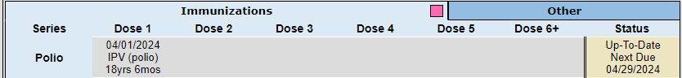

Status screen:

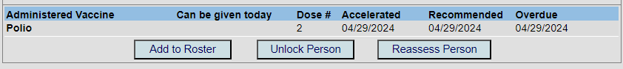

Use the following link for additional guidance:

[Recommended Adult Immunization Schedule for ages 19 years or older (cdc.gov)](https://www.cdc.gov/vaccines/schedules/downloads/adult/adult-combined-schedule.pdf)

General – 1 Item

1. HL7 Update: Addition of "Preferred not to say" option to race and ethnicity fields- PHC1175(Ref# 2810)
2. Recall Letter – Simple wording updates, a sampling is noted below: (Ref# 2843)

* “Health Department” revised to “Local Health Department”
* “Doctor” revised to “Healthcare Provider”
* “Provider(s)” revised to “Healthcare Provider(s)”

If you have questions or need assistance, please contact your Field Representative or

**MCIR SOM Help Desk at** [MDHHS-MCIRHelp@michigan.gov](mailto:MDHHS-MCIRHelp@michigan.gov)**.**