MDHHS – MCIR Release Notes

Version 2024 – MCIR OLTP 2024 24.5.29 – RFC 237088 Release Date: 05/29/2024

Forecasting & Assessment – 4 Items

1. Forecast and evaluate CVX 316 MenABCWY (Penbraya) (Ref # 2684)

History Screen:

Status Screen:



Landscape Report:

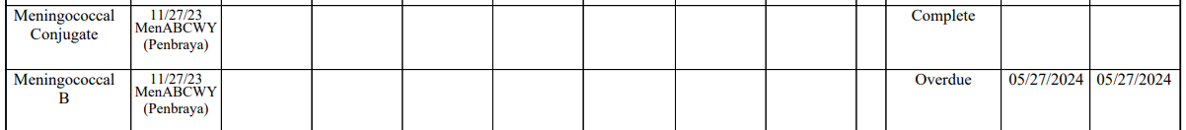

* Persons aged from 10 through 23 may receive MenABCWY (Penbraya) when MenABCWY and MenB are indicated at the same visit.
* The two brands of MenB vaccines are not interchangeable. The series, and booster doses when indicated, must be started, and completed with the same brand of vaccine.
* The MenB component of MenABCWY (Penbraya) is Trumenba. If Penbraya is administered, subsequent doses of MenB should be from the same manufacturer (Trumenba-Pfizer Inc). The following link is provided for additional guidance:
  + [Use of the Pfizer Pentavalent Meningococcal Vaccine Among Persons Aged ≥10 Years: Recommendations of the Advisory Committee on Immunization Practices ― United States, 2023 | MMWR (cdc.gov)](https://www.cdc.gov/mmwr/volumes/73/wr/mm7315a4.htm?s_cid=mm7315a4_w)
* Disclaimer: The MCIR “Quick Look” for Meningococcal B is currently being revised and may not contain the most recent ACIP recommendations.
  + Please refer to the link below:
    - [Meningococcal B Vaccine Recommendations by Age and Risk Factor (immunize.org)](https://www.immunize.org/wp-content/uploads/catg.d/p2035.pdf)

1. MenACWY dose given at ages 9 to under 10 years of age should forecast adolescent dose at age 11yrs (Ref# 2634)

Please refer to the link below:

[Meningococcal ACWY Archives | Immunize.org](https://www.immunize.org/ask-experts/topic/menacwy/#recommendations)

1. Unable to change Compromised Status for Tdap CVX 115 (Ref# 2830)

1. No forecast reported for COVID-19 Moderna 25mg (Ref# 2935)

Information Screen:

Status Screen:



Landscape Report:



General – 2 Item

1. Change HL7 duplicate immunization acknowledgement code to AA (Ref# 2852)
2. Enhance HL7 to provide Warning for incorrect funding eligibility codes (MIA-10) (Ref# 2601)

If you have questions or need assistance, please contact your Field Representative or

**MCIR SOM Help Desk at** [MDHHS-MCIRHelp@michigan.gov](mailto:MDHHS-MCIRHelp@michigan.gov)**.**