MDHHS – MCIR Release Notes

Version 2023 – MCIR OLTP 2023 9.9.2 – RFC 225706 Release Date: October 4, 2023

**Revised: October 18, 2023**

Forecasting & Assessment – 2 Items

1. Some students 11 years of age and older should be considered complete for overall School assessment for Tdap if not in 7th grade. (Ref #2553)

The screen referenced below is a 6th grade student:

Use this link for required school vaccine information:

[Vaccines Required for School Entry in Michigan](https://mcir.org/wp-content/uploads/2021/08/MDHHS-Pub-1378-SchoolEntryReqVaccinesParentsMI_8-2-23-Final.pdf)

1. MCIR deduplication rules have been enhanced to support administration of two (2) CVX 307 (Beyfortus 1ml) to the same child on the same day. (Ref #2584)

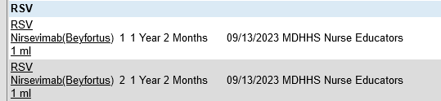

If you have questions or need assistance, please contact your Field Representative, MCIR Region, or

**MCIR SOM Help Desk at** [MDHHS-MCIRHelp@michigan.gov](mailto:MDHHS-MCIRHelp@michigan.gov)**.**