MDHHS – MCIR Release Notes
Version 2023 – MCIR OLTP 2023 9.9.3 – RFC 226231 Release Date: October 14, 2023

Forecasting & Assessment – 1 Item

- CVX 313 Novavax COVID-19 vaccine added, EUA approved (Ref# 2620)

** MCIR is currently reflecting the updated 2023-2024 formulation of Novavax COVID-19 vaccine as complete after one dose, which does not reflect current clinical guidance. There will be a MCIR release on 10/25/23, which will include an update to correctly reflect the updated Novavax vaccine forecasting and assessment.

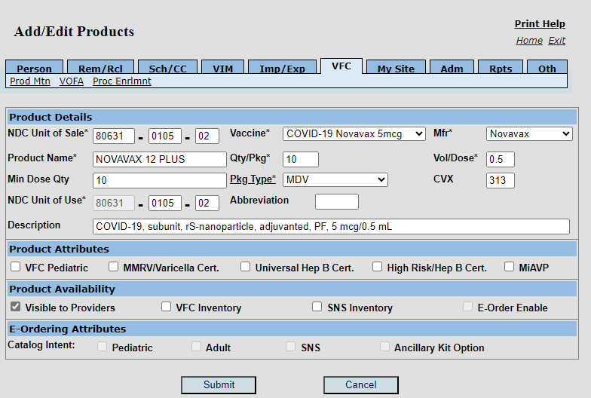
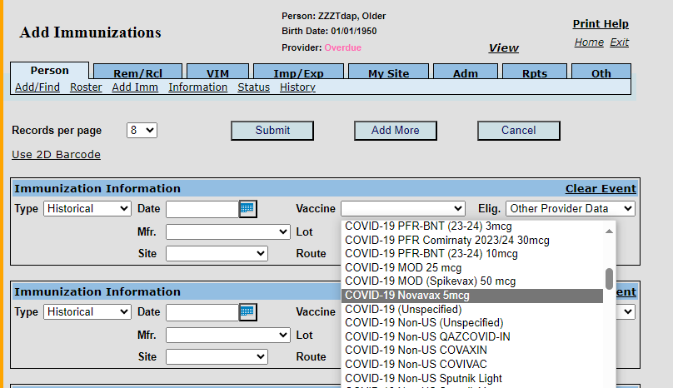
Please see clinical considerations for current clinical guidance for Novavax vaccine:
Interim Clinical Considerations for Use of COVID-19 Vaccines | CDC

If you have questions or need assistance, please contact your Field Representative, MCIR Region, or
MCIR SOM Help Desk at MDHHS-MCIRHelp@michigan.gov.

