MDHHS – MCIR Release Notes
Version 2023 – MCIR OLTP 2023 9.10.1 – RFC 227048 Release Date: November 1, 2023

Forecasting & Assessment – 1 Item
- Remove "consider' recommendation for RSV MAB 200mg for 8 through 19 months (Ref # 2648)
Record with “consider” status per original CDC guidelines
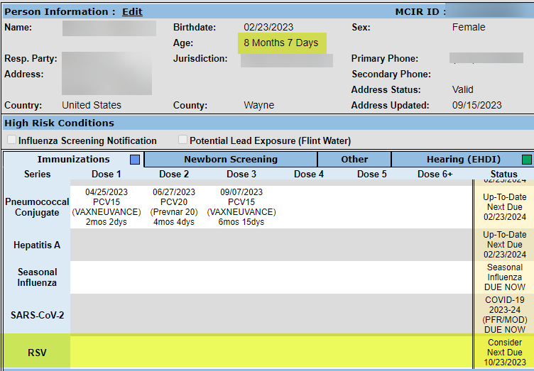
Record with “consider” removed per updated CDC guidelines
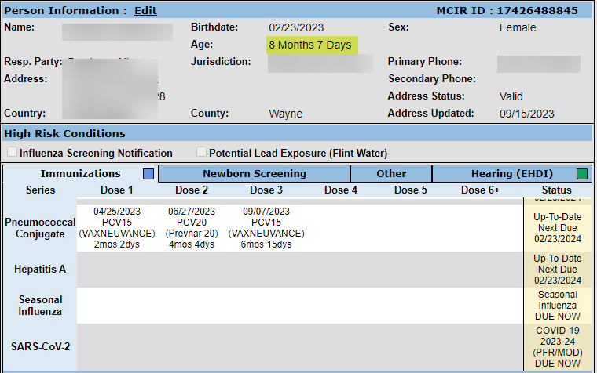
CDC Health Alert Network Advisory issues October 23, 2023
See the attached link for detailed information:
Limited Availability of Nirsevimab in the United States—Interim CDC Recommendations to Protect Infants from Respiratory Syncytial Virus (RSV) during the 2023–2024 Respiratory Virus Season
NOTE: For those in the 8-19 Months age range, who have received a dose; This dose will appear under “Other Administrations” and not assessed or evaluated during this time.
If you have questions or need assistance, please contact your Field Representative or
MCIR SOM Help Desk at MDHHS-MCIRHelp@michigan.gov

